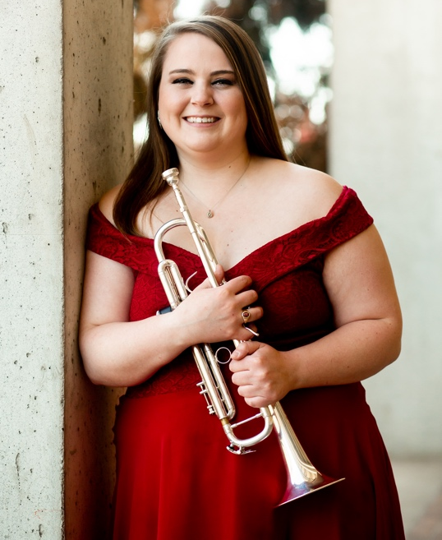
About the Teacher
Ms. Bartleman is a native of Des Moines, Iowa and entering her first of teaching at Roosevelt High School. Prior to this role, she worked as a substitute teacher with the Special School Districts of Saint Louis. During her graduate studies at Southern Illinois University, Ms. Bartleman was a graduate teaching assistant for the Athletic Bands, including the Marching Salukis and SIU Pep Band. As an accomplished musician, she has performed in a wide variety of ensembles, including wind ensemble, orchestra, jazz band, musicals, and chamber music. Ms. Bartleman resides in Saint Louis with her significant other and her two cats, Felix & Ella.
- Bachelor of Arts – Luther College, Music (2021)
- Master of Music – Southern Illinois University Carbondale, Trumpet Performance and Pedagogy (2023)
- Master of Education – University of Missouri Saint Louis, K-12 Instrumental Music Education (anticipated 2026)
Contact Information
Name: Ms. Rachel Bartleman
Email: Rachel.Bartleman@slps.org
Phone Number: (314) 776 – 6040
Room: 111
About the Course
Course Description
The Beginning Percussion course is designed for students with little to no prior experience in percussion instruments. This course will introduce students to the fundamentals of percussion playing, including basic techniques, music reading, rhythm skills, and instrument care. Students will learn to play various percussion instruments, such as snare drum, bass drum, cymbals, mallet instruments, and other auxiliary percussion.
Required Materials
- Drumsticks (Provided)
- Practice pad (Provided)
- Notes worksheets (Provided)
- Music Folder (Provided)
- Pencil
Attendance
Attendance is mandatory for all classes and performances as it is a performance-based class. It is imperative that student attend class to earn the desired grade.
Grading
Points Breakdown
- Daily Attendance: 2 points each day
- Daily Notes Worksheets: 5 points each day
- Quizzes – 10 points each (Midterm, Final)
- Performance(s) – 20 points each
    - Dates are to be determined
Grading Scale
- A: 100 – 90
- B: 89 – 80
- C: 79 – 70
- D: 69 – 60
- F: 59 and below
Class Expectations
- Be respectful, responsible, courteous, and kind
- No inappropriate language
- No talking during instruction
- No food, drink, or chewing gum
- No cell phones or personal technology (headphones, personal laptops)
- Do not touch Smart Board or extra supplies without permission
- No hoods up (must be able to see ears)
- No vandalism (drawing on the walls, ripping down decorations)
- Do not touch other people’s belongings
- Clean up your own mess
Class Procedures
- Students must enter the classroom before the bell rings. Once the bell rings, the classroom door will be locked, and students must have a valid hall pass to enter
- Daily agenda will be posted to the Smart Board for students to review as they enter the classroom.
- The first 5 minutes of class will be allotted for the students to do the following:
  - Getting out all necessary equipment
  - Sit in assigned seats for attendance
- When the teacher stands in the middle of the circle or in the front of the room, all students are to seize playing and conversations to wait for further instructions.
- During class, all students must actively participate and be engaged in what is happening. This includes taking notes, no side conversations or sleeping. Failure to participate with result in a 0 for the day and a contact made home.
- If a student needs to leave during class, they need to have a valid hall pass. See student handbook for further details. Only one student is allowed out of the room at a time.
- At the end of class, the last 5 minutes of class will be allotted for students to put away all equipment. Once a student has completed packing up and put away their belongings, they are to sit in their assigned seats until the bell rings. No students are to line up at the door.
Class Notes
- As part of the daily grade, students must take written notes in class with the provided notes worksheet. They are not to leave the classroom for any reason.
- If a student has a verified absent from class, they will be exempted for that day. If a student has an unexcused absence, they will be given 0 for the day.
- If a student enrolled in the class late due to schedule changes, they will be exempt from point up until the date of their enrollment.
- Make up days will be allotted at the end of each unit in preparation for quizzes
Music Equipment
Instruments
- Due to limited availability of percussion instruments, we will primarily use school provided drum pads and sticks.
- All percussion equipment is not allowed to leave the school
- Excessive damage or negligence of any school equipment will result in a fine to cover the cost of repairs or replacement
Percussion Sticks & Mallets
- Students will provided drum pads & drumsticks use to during class.
- Students are encouraged to practice material learned outside of class. Therefore, students are asked to purchase the following equipment for at home practice:
  - 5A Drumsticks
  - Practice Pad
These can be purchased at Nottelmann Music or on Amazon. If you are unsure about what to get, ask Ms. Bartleman for clarification.
Music Folders
- Students will be assigned a music folder number
- Music binders are not to leave school any time
- Copies of music for at-home practice will be posted to Teams

By signing this form, both the student & parent/guardian acknowledge that they have read the syllabus in-depth and understand the expectations and policies for this course.

Parent/Guardian Signature: __________________________________________________

Student Signature: _________________________________________________________

